L&T FRONT END UI/UX

SAVORY SECRETS

SUBMITTED BY:

Richa felix-2460431

Prardhana s vinod-2460421

Kamireddygari bhavana-2460627

SUBMITTED TO:

INSTITUTE: christ university

SUBMISSION DATE:11/08/25

**ABSTRACT**

This project is a web-based recipe platform designed to provide users with an easy and interactive way to explore, share, and learn recipes from various cuisines. The website aims to combine user-friendly navigation, appealing visuals, and organized categorization to ensure that cooking enthusiasts and beginners alike can access culinary content conveniently. The responsive design ensures accessibility across multiple devices.

**Objective**

* To develop an interactive and visually appealing recipe website.
* To allow users to browse recipes by category, cuisine, or ingredients.
* To provide step-by-step instructions with images for better cooking guidance.
* To create a responsive design that works seamlessly on mobile, tablet, and desktop.
* To improve user engagement through search functionality and easy navigation.

**Scope of the Project**

* **Inclusions:**
  + Homepage with featured recipes and categories.
  + Recipe detail pages with ingredients, cooking steps, and preparation time.
  + Search and filter functionality.
  + Contact/feedback page.
  + Responsive UI for cross-device compatibility.
* **Exclusions:**
  + Advanced account management (login/registration)
  + Integration of video tutorials (future enhancement).

**Tools and Technologies**

* **HTML5** – For structuring the web pages.
* **CSS3** – For styling and layout design.
* **JavaScript** – For interactivity and dynamic content rendering.
* **Bootstrap/Tailwind CSS** – For responsive design.
* **VS Code** – Code editor for development.
* **GitHub** – Version control and project hosting.
* **Google Fonts** – For enhanced typography.
* **Unsplash/Pixabay** – For royalty-free food images.

**HTML Structure Overview**

* **<header>** – Contains the website logo and navigation menu.
* **<nav>** – Links to home, categories, about, and contact pages.
* **<main>** – Displays recipe cards, featured content, and search bar.
* **<section>** – Categorized recipe listings (e.g., Breakfast, Lunch, Dessert).
* **<article>** – Individual recipe details with steps and images.
* **<footer>** – Contact information, social media links, and copyright.

**CSS Styling Strategy**

* **Color Palette** – Warm, food-related colors (orange, green, and beige).
* **Typography** – Clean and readable fonts (e.g., Nunito, Lato).
* **Layout** – Flexbox and CSS Grid for alignment and responsiveness.
* **Hover Effects** – Highlighting buttons and recipe cards for interactivity.
* **Media Queries** – Adapting layouts for mobile, tablet, and desktop views.
* **Consistency** – Reusable CSS classes for uniformity in design.

**Key Features**

* Search and filter recipes by category or ingredients.
* Step-by-step recipe guide with images.
* Responsive layout for multiple devices.
* Easy navigation with a fixed header.
* Attractive image galleries for recipes

**Challenges and Solutions**

| **Challenge** | **Solution** |
| --- | --- |
|  |  |
| *Maintaining layout across different screen sizes. | *Implemented responsive design with CSS Grid and media queries. |
| *Keeping image sizes consistent without distortion. | *Used CSS object fit and fixed aspect ratios for recipe images. |
| *Improving loading speed for images. | *Compressed images using online tools and lazy-loading techniques. |
| *Ensuring readability over background images. | *Added semi-transparent overlays behind text. |

**SAMPLE CODE**

CONTACT:

<!DOCTYPE html>

<html lang="en">

<head>

  <meta charset="utf-8" />

  <meta name="viewport" content="width=device-width,initial-scale=1" />

  <title>Savoury Secrets — Contact</title>

  <link rel="stylesheet" href="style.css" />

</head>

<body>

  <header class="site-header">

    <div class="container header-inner">

      <a href="index.html" class="brand">

        <img src="images/logo.jpg" alt="Savory Secrets logo" class="logo" />

        <span class="brand-name">Savory Secrets</span>

      </a>

      <nav class="nav">

        <a href="index.html" class="nav-link">Home</a>

        <a href="recipes.html" class="nav-link">Recipes</a>

        <a href="contact.html" class="nav-link btn-ghost">Contact</a>

      </nav>

      <button class="hamburger" aria-label="Toggle menu">&#9776;</button>

    </div>

  </header>

  <main class="container contact-page">

    <h1>Contact</h1>

    <p>Have feedback or a recipe to share? Send a message below.</p>

    <form class="contact-form" action="#" method="post" onsubmit="alert('This is a demo contact form. No messages are sent.'); return false;">

      <label>

        <span>Name</span>

        <input type="text" name="name" required />

      </label>

      <label>

        <span>Email</span>

        <input type="email" name="email" required />

      </label>

      <label>

        <span>Message</span>

        <textarea name="message" rows="6" required></textarea>

      </label>

      <button type="submit" class="btn-primary">Send Message</button>

    </form>

  </main>

  <footer class="site-footer">

    <div class="container footer-grid">

      <div>

        <h3>Savory Secrets</h3>

        <p>Classic Indian recipes made approachable.</p>

      </div>

      <nav>

        <a href="index.html">Home</a> · <a href="recipes.html">Recipes</a> · <a href="contact.html">Contact</a>

      </nav>

      <small>© <span id="year3"></span> Savory Secrets</small>

    </div>

  </footer>

  <script>

    document.getElementById('year3').textContent = new Date().getFullYear();

    document.querySelector('.hamburger').addEventListener('click', () => {

      document.querySelector('.nav').classList.toggle('open');

    });

  </script>

</body>

</html>

INDEX:

<!DOCTYPE html>

<html lang="en">

<head>

  <meta charset="utf-8" />

  <meta name="viewport" content="width=device-width,initial-scale=1" />

  <title>Savoury Secrets — Home</title>

  <link rel="stylesheet" href="style.css" />

</head>

<body>

  <header class="site-header">

    <div class="container header-inner">

      <a href="index.html" class="brand">

        <img src="images/logo.jpg" alt="Savory Secrets logo" class="logo" />

        <span class="brand-name">Savory Secrets</span>

      </a>

      <nav class="nav">

        <a href="index.html" class="nav-link">Home</a>

        <a href="recipes.html" class="nav-link">Recipes</a>

        <a href="contact.html" class="nav-link btn-ghost">Contact</a>

      </nav>

      <button class="hamburger" aria-label="Toggle menu">&#9776;</button>

    </div>

  </header>

  <main>

    <section class="hero">

      <div class="container hero-grid">

        <div class="hero-text">

          <h1>Discover the heart of Indian cooking</h1>

          <p>Classic recipes, detailed instructions, and beautiful food photography — curated for home cooks.</p>

          <a href="recipes.html" class="btn-primary">See All Recipes</a>

        </div>

        <figure class="hero-figure">

          <img src="images/butter_chicken.jpg" alt="Butter Chicken" />

          <figcaption>Butter Chicken — savory, creamy, unforgettable.</figcaption>

        </figure>

      </div>

    </section>

    <section class="container featured">

      <h2>Featured Recipes</h2>

      <div class="grid cards">

        <!-- Card 1 -->

        <article class="card">

          <figure>

            <img src="images/biriyani.jpg" alt="Biryani" />

            <figcaption>Hyderabadi Biryani</figcaption>

          </figure>

          <div class="card-body">

            <h3>Hyderabadi Biryani</h3>

            <p>Fragrant layered rice with tender marinated meat and spices.</p>

            <a href="recipes.html#biriyani" class="btn-link">Read Recipe →</a>

          </div>

        </article>

        <!-- Card 2 -->

        <article class="card">

          <figure>

            <img src="images/palak_paneer.jpg" alt="Palak Paneer" />

            <figcaption>Palak Paneer</figcaption>

          </figure>

          <div class="card-body">

            <h3>Palak Paneer</h3>

            <p>Silky spinach gravy with cubes of paneer — nutritious and delicious.</p>

            <a href="recipes.html#palak-paneer" class="btn-link">Read Recipe →</a>

          </div>

        </article>

        <!-- Card 3 -->

        <article class="card">

          <figure>

            <img src="images/masala_dosa.jpg" alt="Masala Dosa" />

            <figcaption>Masala Dosa</figcaption>

          </figure>

          <div class="card-body">

            <h3>Masala Dosa</h3>

            <p>Crisp rice crepe filled with spiced potato masala.</p>

            <a href="recipes.html#masala-dosa" class="btn-link">Read Recipe →</a>

          </div>

        </article>

        <!-- Card 4 -->

        <article class="card">

          <figure>

            <img src="images/chole.jpg" alt="Chole" />

            <figcaption>Chole</figcaption>

          </figure>

          <div class="card-body">

            <h3>Chole (Chickpea Curry)</h3>

            <p>Hearty, tangy chickpea curry perfect with bhature or rice.</p>

            <a href="recipes.html#chole" class="btn-link">Read Recipe →</a>

          </div>

        </article>

      </div>

    </section>

    <section class="container categories">

      <h2>Explore Categories</h2>

      <div class="category-grid">

        <a href="recipes.html#main-course" class="chip">Main Course</a>

        <a href="recipes.html#breakfast" class="chip">Breakfast</a>

        <a href="recipes.html#snacks" class="chip">Snacks</a>

        <a href="recipes.html#dessert" class="chip">Desserts</a>

      </div>

    </section>

  </main>

  <footer class="site-footer">

    <div class="container footer-grid">

      <div>

        <h3>Savory Secrets</h3>

        <p>Classic Indian recipes made approachable.</p>

      </div>

      <nav>

        <a href="index.html">Home</a> · <a href="recipes.html">Recipes</a> · <a href="contact.html">Contact</a>

      </nav>

      <small>© <span id="year"></span> Savory Secrets</small>

    </div>

  </footer>

  <script>

    // small script for year and responsive nav

    document.getElementById('year').textContent = new Date().getFullYear();

    const btn = document.querySelector('.hamburger');

    const nav = document.querySelector('.nav');

    btn.addEventListener('click', () => {

      nav.classList.toggle('open');

    });

  </script>

</body>

</html>

RECIPES:

<!DOCTYPE html>

<html lang="en">

<head>

  <meta charset="utf-8" />

  <meta name="viewport" content="width=device-width,initial-scale=1" />

  <title>Savoury Secrets — Recipes</title>

  <link rel="stylesheet" href="style.css" />

</head>

<body>

  <header class="site-header">

    <div class="container header-inner">

      <a href="index.html" class="brand">

        <img src="images/logo.jpg" alt="Savory Secrets logo" class="logo" />

        <span class="brand-name">Savory Secrets</span>

      </a>

      <nav class="nav">

        <a href="index.html" class="nav-link">Home</a>

        <a href="recipes.html" class="nav-link">Recipes</a>

        <a href="contact.html" class="nav-link btn-ghost">Contact</a>

      </nav>

      <button class="hamburger" aria-label="Toggle menu">&#9776;</button>

    </div>

  </header>

  <main class="container recipes-page">

    <h1>Recipes</h1>

    <!-- Section: Main Course -->

    <section id="main-course" aria-label="Main course recipes">

      <h2>Main Course</h2>

      <!-- Butter Chicken -->

      <article id="butter-chicken" class="recipe">

        <header class="recipe-header">

          <h3>Butter Chicken</h3>

          <p class="meta">Prep: 20m • Cook: 40m • Serves 4</p>

        </header>

        <div class="recipe-grid">

          <figure>

            <img src="images/butter_chicken.jpg" alt="Butter Chicken" />

            <figcaption>Butter Chicken</figcaption>

          </figure>

          <div class="recipe-content">

            <h4>Ingredients</h4>

            <ul>

              <li>500g boneless chicken, cut into pieces</li>

              <li>1 cup tomato puree</li>

              <li>1/2 cup cream</li>

              <li>2 tbsp butter</li>

              <li>1 tbsp ginger-garlic paste</li>

              <li>1 tsp garam masala, 1 tsp chili powder, salt to taste</li>

              <li>2 tbsp yogurt (optional)</li>

            </ul>

            <h4>Instructions</h4>

            <ol>

              <li>Marinate chicken with yogurt, ginger-garlic paste, chili powder, and salt for 30 minutes (optional).</li>

              <li>Pan-sear chicken until lightly browned and set aside.</li>

              <li>In the same pan, melt butter, add tomato puree and spices; cook 8–10 minutes.</li>

              <li>Add cream, return chicken to the sauce, simmer 10–12 minutes until cooked through.</li>

              <li>Finish with garam masala and a knob of butter. Serve with naan or rice.</li>

            </ol>

            <p class="tags">Tags: <a href="#main-course">Main Course</a></p>

          </div>

        </div>

      </article>

      <!-- Palak Paneer -->

      <article id="palak-paneer" class="recipe">

        <header><h3>Palak Paneer</h3><p class="meta">Prep: 15m • Cook: 25m • Serves 3-4</p></header>

        <div class="recipe-grid">

          <figure>

            <img src="images/palak_paneer.jpg" alt="Palak Paneer" />

            <figcaption>Palak Paneer</figcaption>

          </figure>

          <div class="recipe-content">

            <h4>Ingredients</h4>

            <ul>

              <li>300g spinach (palak), cleaned</li>

              <li>200g paneer, cubed</li>

              <li>1 onion, 1 tomato, ginger-garlic paste</li>

              <li>1 tsp cumin seeds, 1/2 tsp garam masala</li>

            </ul>

            <h4>Instructions</h4>

            <ol>

              <li>Blanch spinach, blend to a smooth puree.</li>

              <li>Sauté onions, tomatoes, and spices; add spinach puree and simmer.</li>

              <li>Add paneer cubes and cook 4–5 minutes. Finish with a drizzle of cream (optional).</li>

            </ol>

            <p class="tags">Tags: <a href="#main-course">Main Course</a></p>

          </div>

        </div>

      </article>

      <!-- Chole -->

      <article id="chole" class="recipe">

        <header><h3>Chole (Chickpea Curry)</h3><p class="meta">Prep: 10m • Cook: 30-40m • Serves 4</p></header>

        <div class="recipe-grid">

          <figure>

            <img src="images/chole.jpg" alt="Chole" />

            <figcaption>Chole</figcaption>

          </figure>

          <div class="recipe-content">

            <h4>Ingredients</h4>

            <ul>

              <li>2 cups cooked chickpeas (or canned)</li>

              <li>1 large onion, 2 tomatoes, ginger-garlic paste</li>

              <li>2 tsp chole masala (or garam masala + ground coriander)</li>

              <li>1 tsp amchur (dry mango powder) or a squeeze of lemon</li>

            </ul>

            <h4>Instructions</h4>

            <ol>

              <li>Sauté onions, add ginger-garlic and tomatoes until soft.</li>

              <li>Add spices and chickpeas with a splash of water; simmer 15–20 minutes.</li>

              <li>Adjust tanginess with amchur or lemon. Garnish with coriander.</li>

            </ol>

            <p class="tags">Tags: <a href="#main-course">Main Course</a></p>

          </div>

        </div>

      </article>

      <!-- Biryani -->

      <article id="biriyani" class="recipe">

        <header><h3>Hyderabadi Biryani</h3><p class="meta">Prep: 25m • Cook: 1h • Serves 4-6</p></header>

        <div class="recipe-grid">

          <figure>

            <img src="images/biriyani.jpg" alt="Biriyani" />

            <figcaption>Hyderabadi Biriyani</figcaption>

          </figure>

          <div class="recipe-content">

            <h4>Ingredients</h4>

            <ul>

              <li>500g basmati rice, 500g chicken (or vegetables)</li>

              <li>yogurt, fried onions, biryani masala, mint, coriander</li>

              <li>1 tsp saffron soaked in warm milk (optional)</li>

            </ul>

            <h4>Instructions</h4>

            <ol>

              <li>Par-cook rice; marinate chicken with spices and yogurt.</li>

              <li>Layer rice and chicken in a heavy pot, add fried onions, saffron milk, and seal lid.</li>

              <li>Cook on low heat (dum) for 25–35 minutes until aromatic and cooked.</li>

            </ol>

            <p class="tags">Tags: <a href="#main-course">Main Course</a></p>

          </div>

        </div>

      </article>

    </section>

    <!-- Breakfast -->

    <section id="breakfast" aria-label="Breakfast recipes">

      <h2>Breakfast</h2>

      <!-- Masala Dosa -->

      <article id="masala-dosa" class="recipe">

        <header><h3>Masala Dosa</h3><p class="meta">Prep: 20m (batter longer) • Cook: 20m • Serves 3-4</p></header>

        <div class="recipe-grid">

          <figure>

            <img src="images/masala_dosa.jpg" alt="Masala Dosa" />

            <figcaption>Masala Dosa</figcaption>

          </figure>

          <div class="recipe-content">

            <h4>Ingredients</h4>

            <ul>

              <li>Dosa batter (rice + urad dal, fermented) or store-bought</li>

              <li>3 medium potatoes, mustard seeds, curry leaves, green chilies</li>

            </ul>

            <h4>Instructions</h4>

            <ol>

              <li>Prepare potato masala: sauté mustard seeds, curry leaves, onions and add boiled, mashed potatoes and spices.</li>

              <li>Spread dosa batter on hot skillet, place filling inside, fold and serve with chutney and sambar.</li>

            </ol>

            <p class="tags">Tags: <a href="#breakfast">Breakfast</a></p>

          </div>

        </div>

      </article>

    </section>

    <!-- Snacks -->

    <section id="snacks" aria-label="Snack recipes">

      <h2>Snacks</h2>

      <!-- Samosa -->

      <article id="samosa" class="recipe">

        <header><h3>Samosa</h3><p class="meta">Prep: 30m • Cook: 20m • Makes 8–10</p></header>

        <div class="recipe-grid">

          <figure>

            <img src="images/samosa.jpg" alt="Samosa" />

            <figcaption>Samosa</figcaption>

          </figure>

          <div class="recipe-content">

            <h4>Ingredients</h4>

            <ul>

              <li>For dough: 2 cups all-purpose flour, oil, salt</li>

              <li>Filling: 3 potatoes, peas, cumin, garam masala</li>

            </ul>

            <h4>Instructions</h4>

            <ol>

              <li>Make firm dough and rest. Prepare spiced potato filling.</li>

              <li>Roll dough into small circles, fill, seal and deep-fry until golden.</li>

            </ol>

            <p class="tags">Tags: <a href="#snacks">Snacks</a></p>

          </div>

        </div>

      </article>

    </section>

    <!-- Dessert -->

    <section id="dessert" aria-label="Dessert recipes">

      <h2>Desserts</h2>

      <!-- Gulab Jamun -->

      <article id="gulab-jamun" class="recipe">

        <header><h3>Gulab Jamun</h3><p class="meta">Prep: 20m • Cook: 20m • Serves 4</p></header>

        <div class="recipe-grid">

          <figure>

            <img src="images/gulab_jamun.jpg" alt="Gulab Jamun" />

            <figcaption>Gulab Jamun</figcaption>

          </figure>

          <div class="recipe-content">

            <h4>Ingredients</h4>

            <ul>

              <li>250g milk powder or khoya, 1 cup flour, sugar syrup flavored with cardamom</li>

            </ul>

            <h4>Instructions</h4>

            <ol>

              <li>Make soft dough from milk solids/flour, shape into small balls. Fry on low heat until dark golden.</li>

              <li>Soak fried balls in warm sugar syrup for at least 30 minutes before serving.</li>

            </ol>

            <p class="tags">Tags: <a href="#dessert">Dessert</a></p>

          </div>

        </div>

      </article>

    </section>

  </main>

  <footer class="site-footer">

    <div class="container footer-grid">

      <div>

        <h3>Savory Secrets</h3>

        <p>Classic Indian recipes made approachable.</p>

      </div>

      <nav>

        <a href="index.html">Home</a> · <a href="recipes.html">Recipes</a> · <a href="contact.html">Contact</a>

      </nav>

      <small>© <span id="year2"></span> Savoury Secrets</small>

    </div>

  </footer>

  <script>

    document.getElementById('year2').textContent = new Date().getFullYear();

    document.querySelector('.hamburger').addEventListener('click', () => {

      document.querySelector('.nav').classList.toggle('open');

    });

  </script>

</body>

</html>

STYLE:

/* Base & layout */

:root{

  --bg1: #f7f3ff; /* pale lavender */

  --bg2: #fff7f3; /* pale peach */

  --accent: #f6a6c1; /* pastel pink */

  --accent-2: #a3d5ff; /* pastel blue */

  --muted: #6b6b6b;

  --card-bg: rgba(255,255,255,0.85);

  --glass: rgba(255,255,255,0.6);

  --radius: 14px;

  --container: 1100px;

  --transition: 280ms cubic-bezier(.2,.8,.2,1);

}

* { box-sizing: border-box; }

html,body { height:100%; }

body {

  margin:0; font-family: Inter, system-ui, -apple-system, "Segoe UI", Roboto, "Helvetica Neue", Arial;

  background: linear-gradient(120deg,var(--bg1),var(--bg2));

  color:#222; -webkit-font-smoothing:antialiased;

  -moz-osx-font-smoothing:grayscale;

}

/* Container */

.container {

  max-width: var(--container); margin: 0 auto; padding: 1.25rem;

}

/* Header */

.site-header {

  position: sticky; top:0; z-index:20;

  backdrop-filter: blur(6px);

  background: linear-gradient(90deg, rgba(255,255,255,0.6), rgba(255,255,255,0.35));

  border-bottom: 1px solid rgba(0,0,0,0.04);

}

.header-inner { display:flex; align-items:center; justify-content:space-between; gap:1rem; padding:0.75rem 0; }

.brand { display:flex; align-items:center; gap:.6rem; text-decoration:none; color:inherit; }

.logo { width: 100px; height:auto; }

.brand-name { font-weight:700; letter-spacing:.4px; font-size:2rem; }

/* Nav */

.nav { display:flex; gap:.75rem; align-items:center; }

.nav-link { text-decoration:none; color:var(--muted); padding:.5rem .6rem; border-radius:10px; transition:var(--transition); }

.nav-link:hover { color:#111; transform:translateY(-2px); box-shadow: 0 6px 18px rgba(170,170,170,0.06); }

.btn-ghost { border:1px solid rgba(0,0,0,0.06); padding:.45rem .6rem; background:transparent; }

/* Hamburger for mobile */

.hamburger { display:none; background:transparent; border:none; font-size:1.5rem; padding:.35rem; }

/* Hero */

.hero { padding:2rem 0; }

.hero-grid { display:grid; grid-template-columns: 1fr 420px; gap:2rem; align-items:center; }

.hero-text h1 { font-size:2rem; margin:0 0 .5rem; }

.hero-text p { color:var(--muted); margin:0 0 1rem; }

.hero-figure img { width:100%; border-radius:16px; box-shadow:0 12px 40px rgba(0,0,0,0.08); display:block; }

/* Buttons */

.btn-primary {

  display:inline-block; padding:.6rem 1rem; border-radius:10px; text-decoration:none;

  background: linear-gradient(90deg,var(--accent),var(--accent-2));

  color:white; font-weight:600; box-shadow: 0 8px 24px rgba(163,213,255,0.12);

  transition: transform var(--transition);

}

.btn-primary:hover { transform:translateY(-4px); }

/* Featured cards */

.featured h2, .categories h2 { margin-top:1rem; }

.grid.cards { display:grid; grid-template-columns: repeat(auto-fit,minmax(220px,1fr)); gap:1.25rem; margin-top:1rem; }

.card { background:var(--card-bg); border-radius:12px; overflow:hidden; box-shadow: 0 8px 30px rgba(10,10,10,0.04); transition: transform var(--transition); }

.card:hover { transform:translateY(-6px); }

.card figure { margin:0; height:160px; overflow:hidden; }

.card img { width:100%; height:100%; object-fit:cover; display:block; transition: transform var(--transition); }

.card:hover img { transform: scale(1.06); }

.card-body { padding:1rem; }

.card-body h3 { margin:.15rem 0; }

.btn-link { color:var(--accent-2); text-decoration:none; font-weight:600; }

/* categories */

.category-grid { display:flex; gap:.5rem; flex-wrap:wrap; margin-top:.75rem; }

.chip { padding:.45rem .8rem; border-radius:999px; background:var(--glass); text-decoration:none; color:var(--muted); }

/* Recipes page */

.recipes-page h1 { margin-top:1rem; }

.recipe { margin:1.25rem 0; padding:1rem; background:rgba(255,255,255,0.6); border-radius:12px; box-shadow:0 6px 18px rgba(0,0,0,0.04); }

.recipe-grid { display:grid; grid-template-columns: 320px 1fr; gap:1rem; align-items:start; }

.recipe figure img { width:100%; border-radius:8px; height:220px; object-fit:cover; }

.recipe-content h4 { margin:.5rem 0 .25rem; }

.meta { color:var(--muted); font-size:.92rem; margin: .25rem 0 .6rem; }

/* Contact & form */

.contact-form { max-width:680px; background:rgba(255,255,255,0.6); padding:1rem; border-radius:12px; display:grid; gap:.75rem; }

.contact-form label { display:block; }

.contact-form span { display:block; font-weight:600; margin-bottom:.25rem; }

.contact-form input, .contact-form textarea { width:100%; padding:.6rem; border-radius:8px; border:1px solid rgba(0,0,0,0.08); background:transparent; }

/* Footer */

.site-footer { margin-top:2rem; padding:1.25rem 0; color:var(--muted); background:transparent; border-top:1px solid rgba(0,0,0,0.04); }

.footer-grid { display:grid; grid-template-columns: 1fr auto 150px; gap:1rem; align-items:center; }

/* Responsive */

@media (max-width:900px) {

  .hero-grid { grid-template-columns: 1fr; }

  .recipe-grid { grid-template-columns: 1fr; }

  .grid.cards { grid-template-columns: repeat(2,1fr); }

}

@media (max-width:640px) {

  .container { padding:.8rem; }

  .grid.cards { grid-template-columns: 1fr; }

  .nav { display:none; position:absolute; right:1rem; top:70px; background:rgba(255,255,255,0.95); padding:.8rem; border-radius:12px; box-shadow:0 8px 30px rgba(0,0,0,0.08); }

  .nav.open { display:flex; flex-direction:column; gap:.4rem; }

  .hamburger { display:block; }

  .hero-text h1 { font-size:1.5rem; }

  .footer-grid { grid-template-columns: 1fr; text-align:center; }}

OUTPUT:

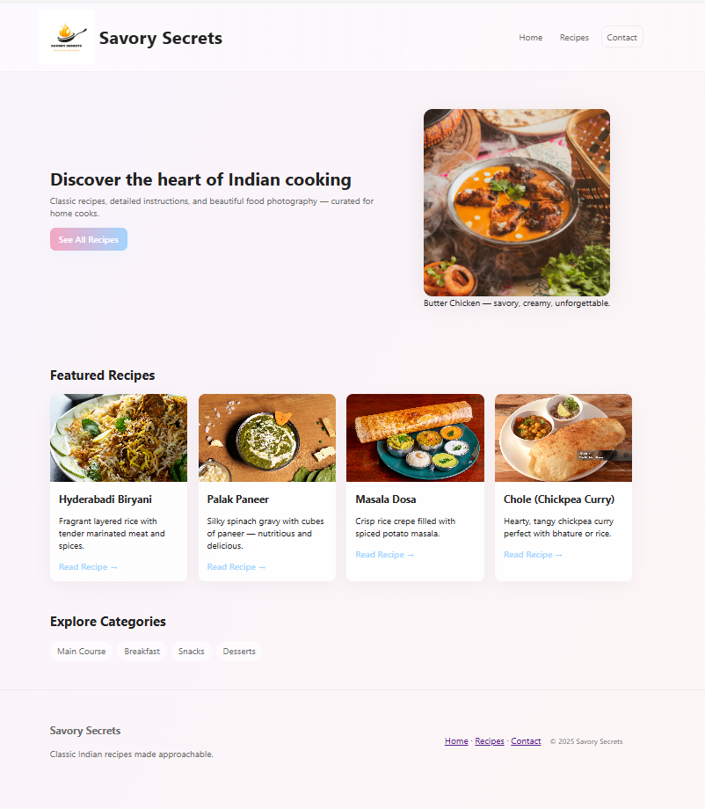

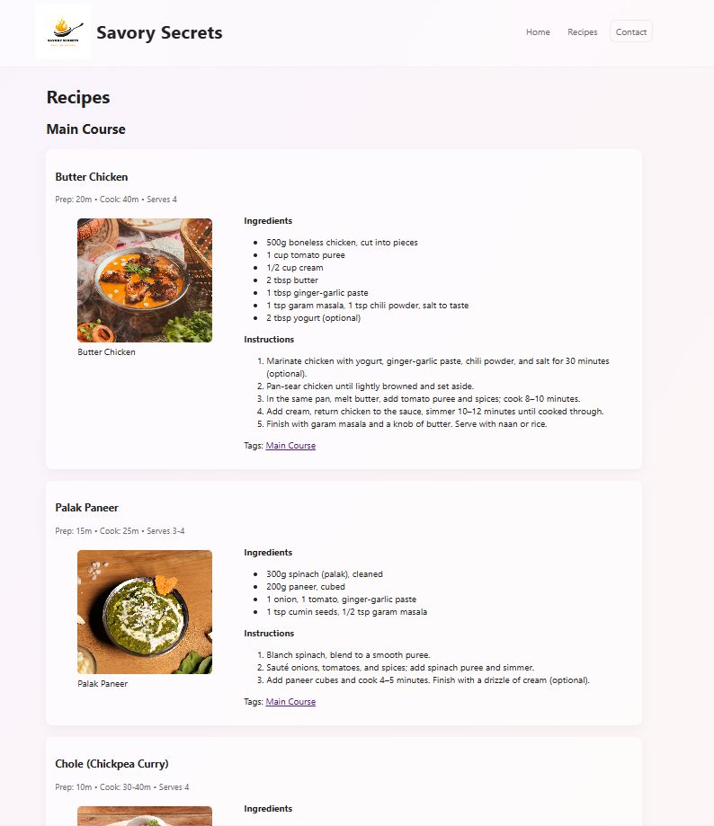

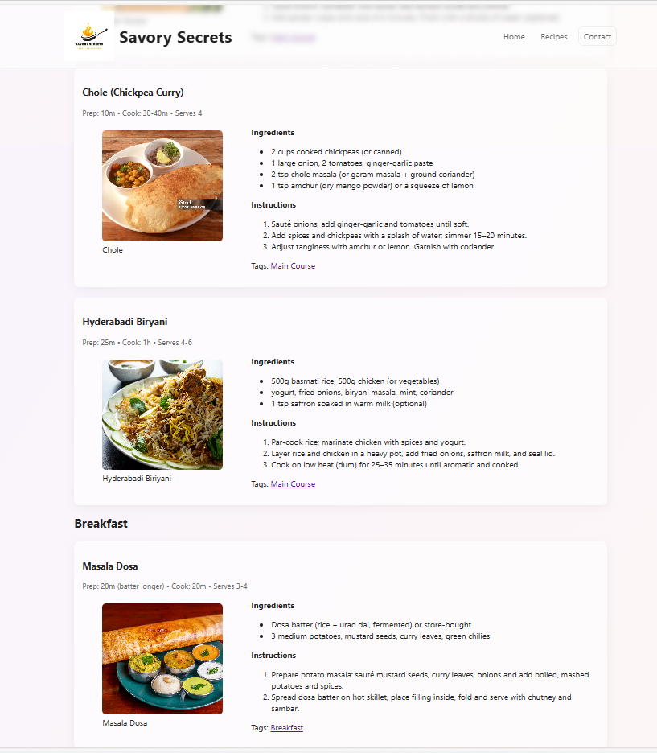

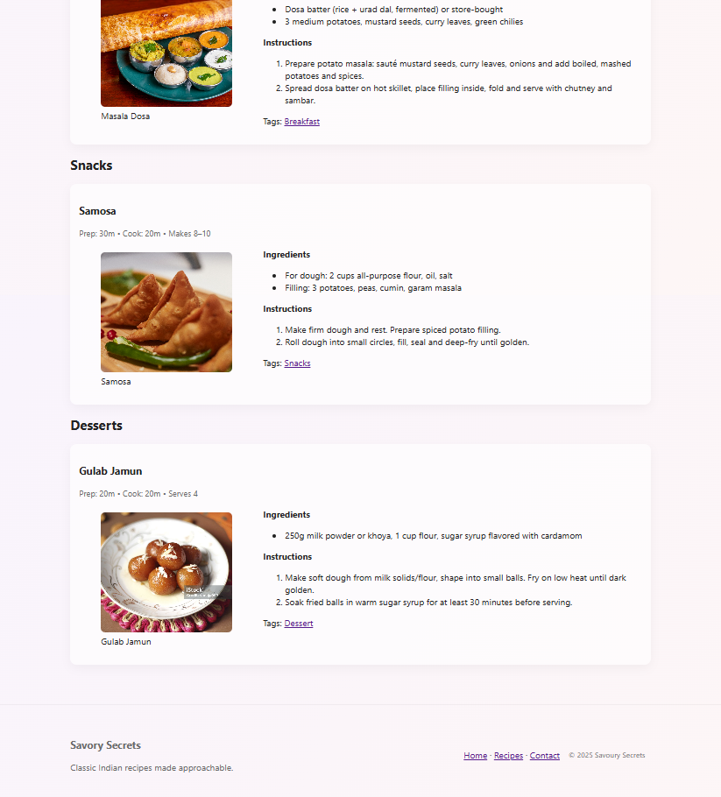

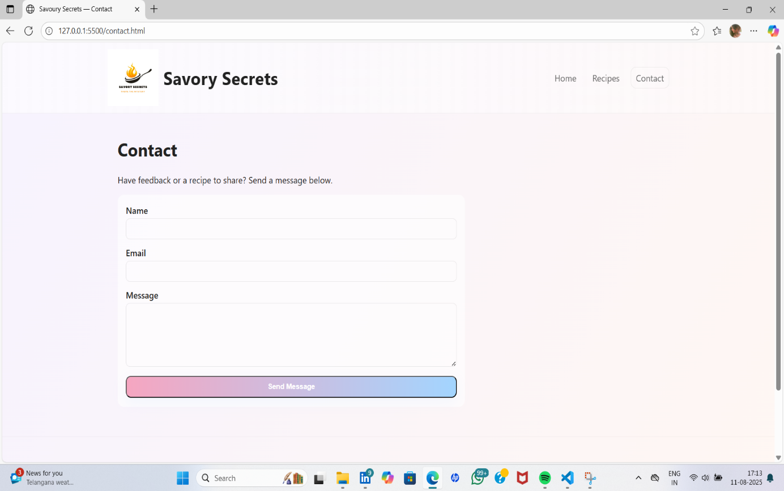

CONCLUSION:

The recipe website successfully provides an easy-to-use, visually appealing, and responsive platform for food lovers. With an organized structure, consistent styling, and a focus on user experience, the website meets its objectives and offers a strong foundation for future enhancements such as user accounts, video tutorials, and advanced recipe sharing option.

REFERENCE:

* W3Schools – HTML, CSS, and JavaScript Tutorials

* MDN Web Docs – Web Development Resources

*Unsplash – Free Food Images

* Google Fonts